# Laboratory 7

**Combinational Circuits-III**

**Decimal to BCD Encoder and Decoders**

1. Introduction and Purpose of Experiment

Students will learn to design and implement a circuit for Decimal to BCD Encoder.

1. Aim and Objectives

**Aim:** Design and implement a circuit for Decimal to BCD Encoder

**Objectives:** At the end of this lab, the student will be able to

* Develop a circuit for Decimal to BCD Encoder
* Understand the basics of Decoders

1. Experimental Procedure
   1. Write truth table and block diagram for Decimal to BCD Encoder
   2. Construct the circuits for Decimal to BCD Encoder using appropriate ICs. Verify the functionality and show the output to the course leader
   3. Using an example, describe how a decoder can be implemented using a Demultiplexer.

Your document should include:

* Handwritten truth table and block diagrams for the circuit in 3(a).
* Answer to 3(c)

2:4 decoders

Circuit diagram truth table

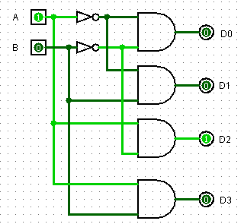 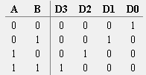

3:8 decoders

Circuit diagram truth table

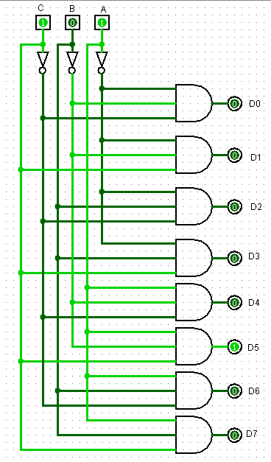 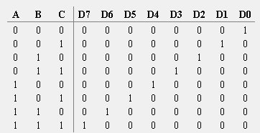

4:2 encoders

Circuit diagram truth table

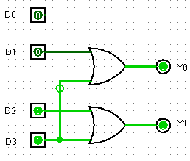 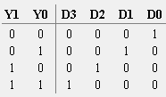

8:3 encoders

Circuit diagram truth table

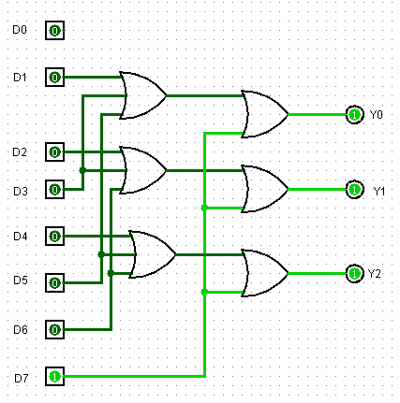 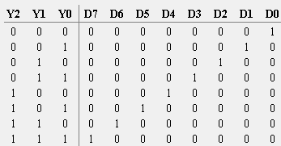

4:2 priority encoders

Circuit diagram truth table

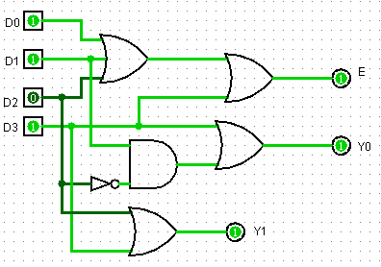 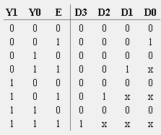

Bcd to 7 segment display

Block diagram truth table

